**SNAP Outreach for Schools**

This toolkit includes social media graphics and captions in English and Spanish that schools and other community organizations can use to promote SNAP. The materials encourage families to use a prescreening tool ([SNAPHelpNY.org](https://hungersolutionsny.org/find-food-help/snap/snap-eligibility-tool/)) that helps them learn if they may be eligible and get more information about applying for SNAP.

**Graphics****:**

* Right-click on an image to save it to your computer

**Sample Captions****:**

* Copy and paste the text and pair with an image.
* Link to SNAPHelpNY.org to direct families to the SNAP eligibility prescreening tool and/or encourage them to text SNAPNY to 844-366-3435 to learn more

**Graphics**

Right-click on any image to save it to your computer.

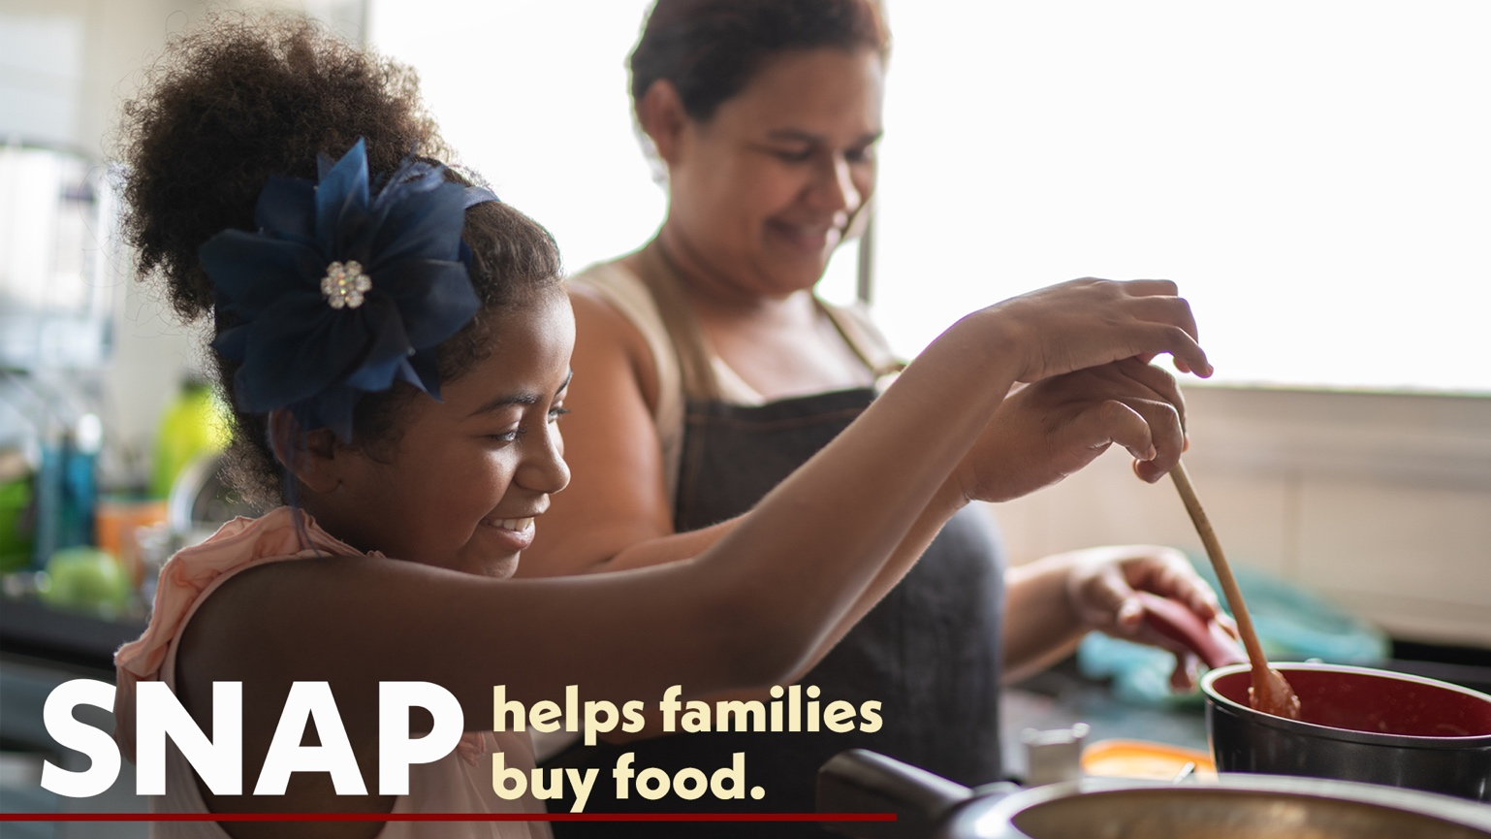

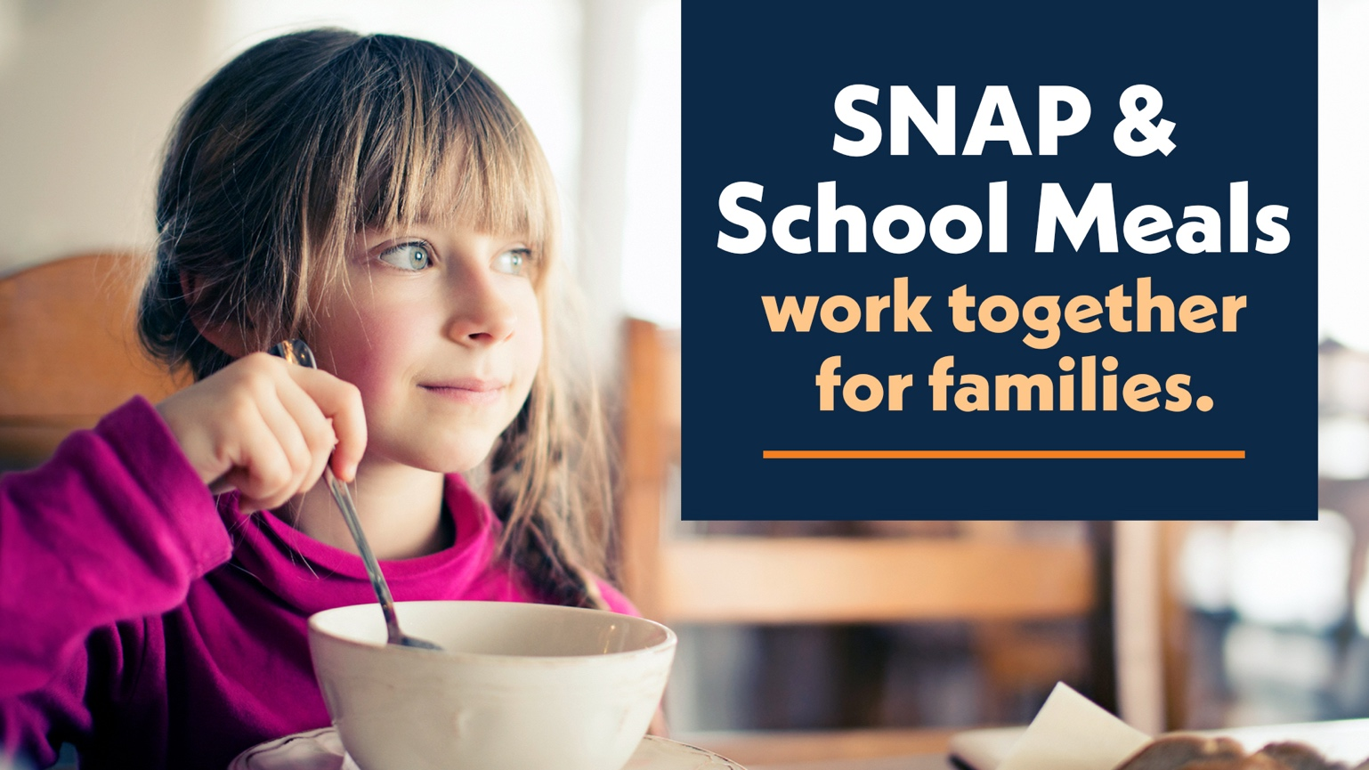

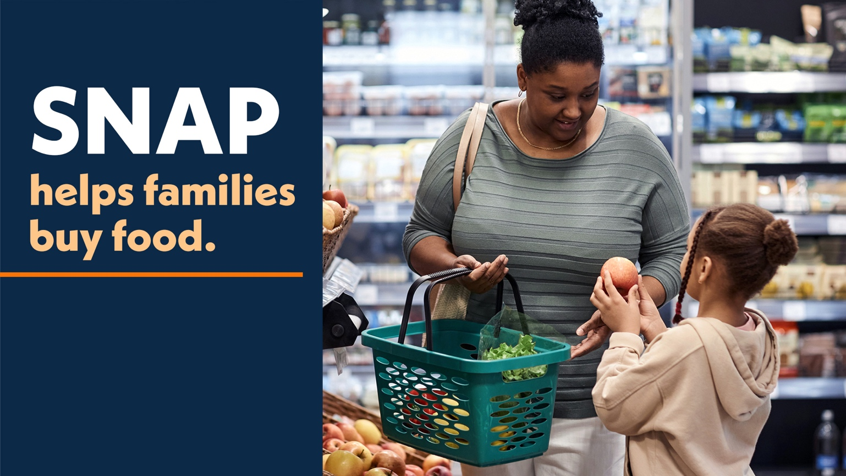

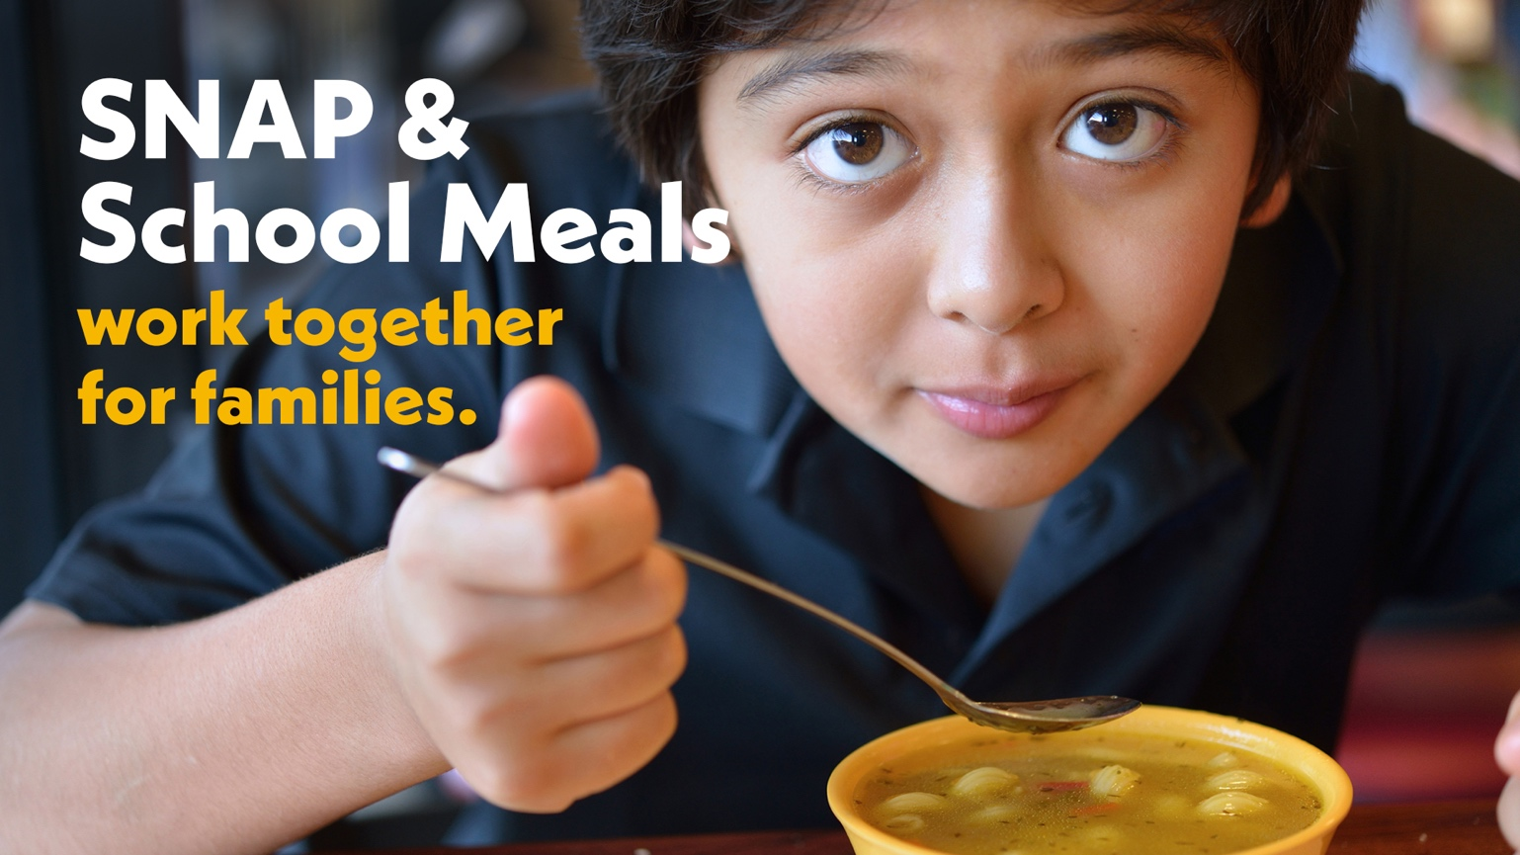

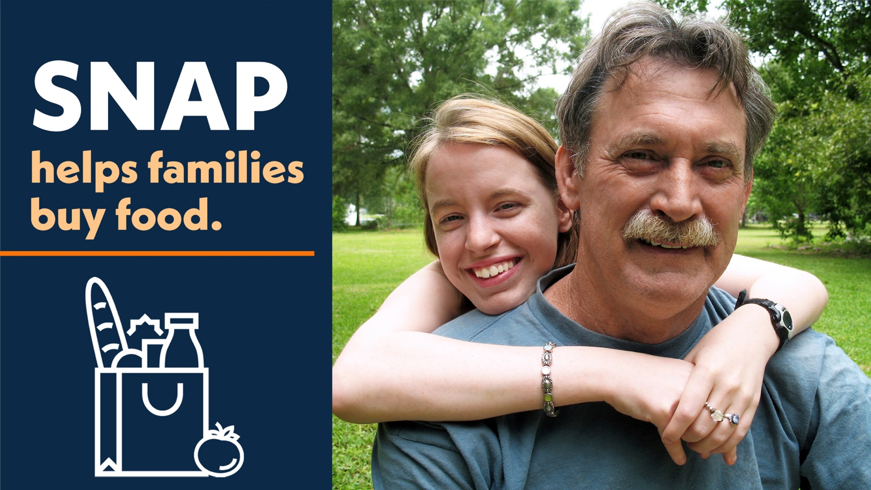

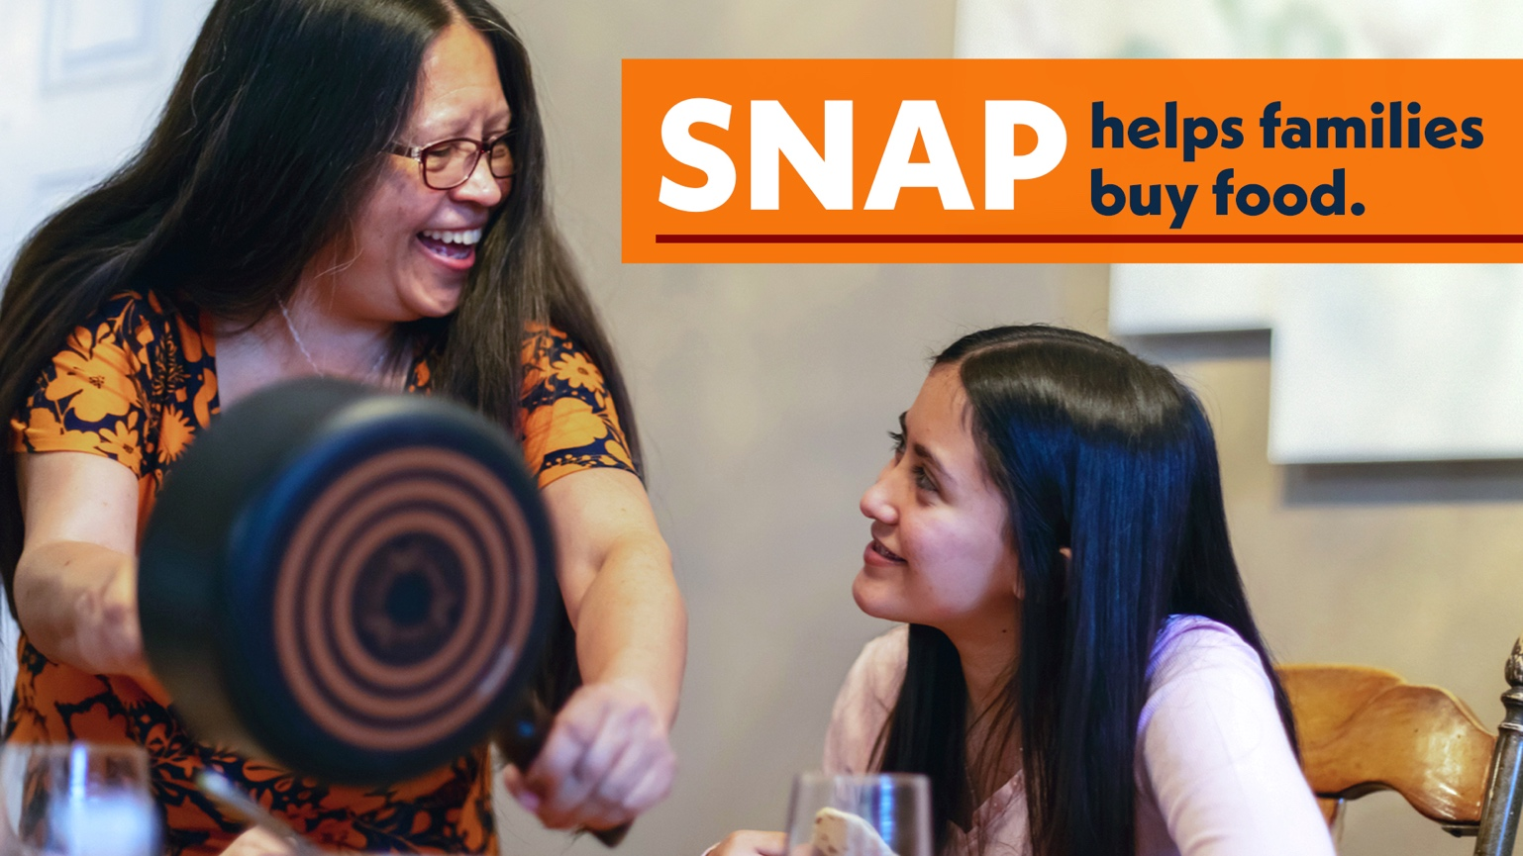

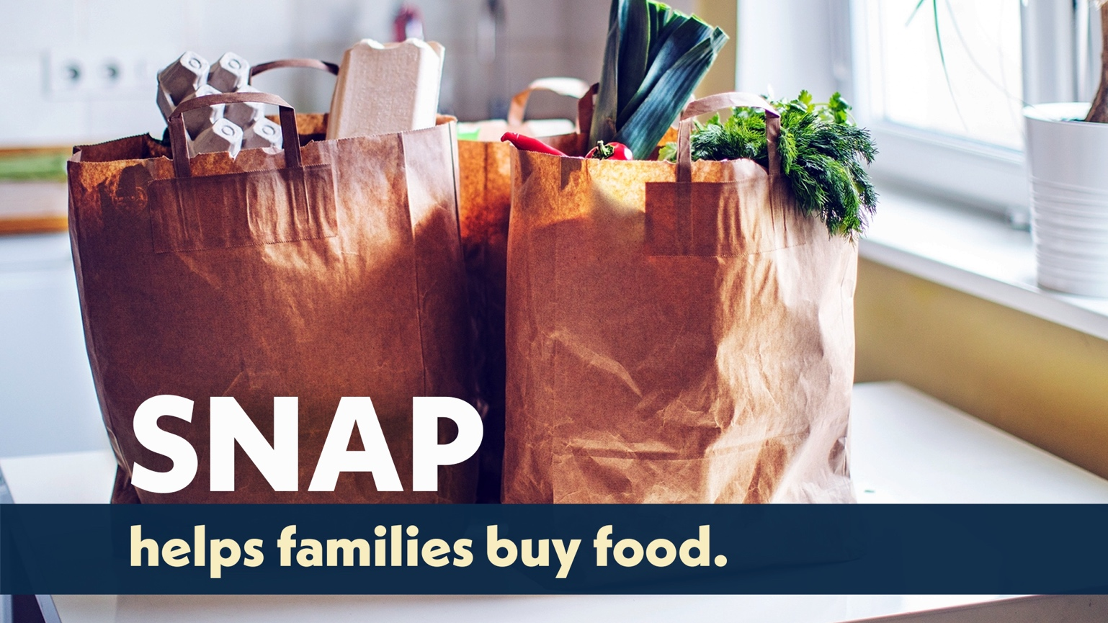

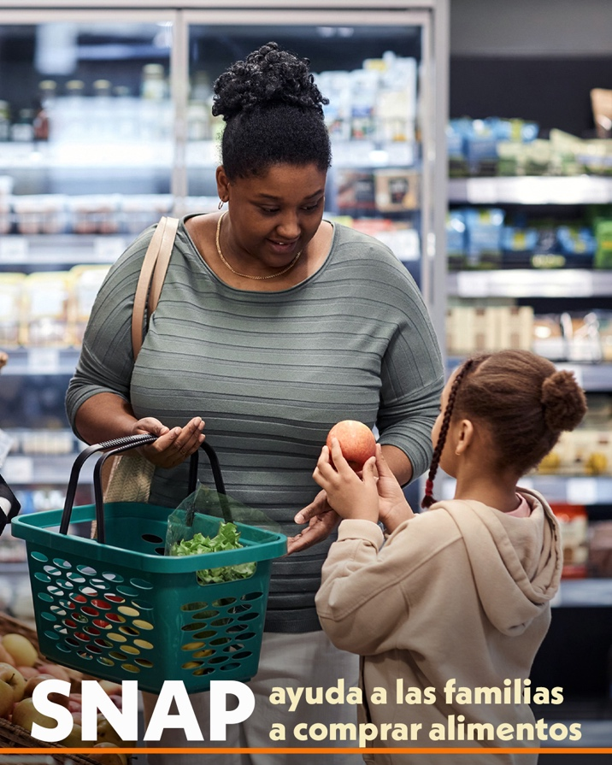

**Sample Captions**

Hunger happens everywhere, including in our school community. SNAP helps families afford more food so children have the nourishment they need to learn and grow. Visit SNAPHelpNY.org and answer a few questions to see if you may be eligible.

El hambre ocurre en todas partes, incluso en nuestra comunidad escolar. SNAP ayuda a las familias a pagar más alimentos para que los niños tengan la nutrición que necesitan para aprender y crecer. Visite SNAPHelpNY.org y responda algunas preguntas para ver si puede ser elegible.

School meals and SNAP work together to nourish children. With SNAP you will have more to spend at the grocery store and your kids will automatically qualify for free school meals. You can get help applying for SNAP. It’s free and confidential. Visit SNAPHelpNY.org or text SNAPNY to 844-366-3435.

Las comidas escolares y SNAP trabajan conjuntamente para nutrir a los niños. Con SNAP tendrá más para gastar en supermercados y sus hijos calificarán automáticamente para recibir comidas escolares gratuitas. Podemos ayudarle a solicitar el SNAP. Es gratuito y confidencial. Visite SNAPHelpNY.org o envíe un mensaje de texto a SNAPNY al 844-366-3435.

With grocery prices on the rise, many families need extra help. SNAP can stretch your food budget so you will have more to spend at the grocery store. Answer a few questions from Hunger Solutions New York to see if you may be eligible. Visit SNAPHelpNY.org or text SNAPNY to 844-366-3435

Con el aumento de los precios de los alimentos, muchas familias necesitan ayuda adicional. El programa SNAP puede extender su presupuesto de alimentos, así tenga más para gastar en el supermercado. Responda algunas preguntas de Hunger Solutions New York para ver si puede ser elegible. Visite SNAPHelpNY.org o envíe un mensaje de texto a SNAPNY al 844-366-3435

Nutritious food is important for kids to do well in school. SNAP can help your family afford more food at the grocery store. Answer a few easy questions from Hunger Solutions New York to see if your family may be eligible for SNAP. Visit SNAPHelpNY.org or text SNAPNY to 844-366-3435.

Los alimentos nutritivos son importantes para que a los niños les vaya bien en la escuela. SNAP puede ayudar a su familia a adquirir más alimentos en el supermercado. Responda algunas preguntas sencillas de Hunger Solutions New York para ver si su familia puede ser elegible para SNAP. Visite SNAPHelpNY.org o envíe un mensaje de texto a SNAPNY al 844-366-3435.

The last few years have been difficult for families and many need help buying food. SNAP can boost your food budget so you’ll have more to spend at the grocery store. Visit SNAPHelpNY.org and answer a few questions to see if you may be eligible.

Los últimos años han sido difíciles para las familias, y muchas necesitan ayuda para comprar alimentos. El programa SNAP puede aumentar su presupuesto de alimentos, así tenga más para gastar en el supermercado. Visite SNAPHelpNY.org y responda algunas preguntas para ver si puede ser elegible.

If you could use help getting the food you need, SNAP might be right for you. Visit SNAPHelpNY.org or text SNAPNY to 844-366-3435 to see if you may be eligible.

Si le vendría bien recibir ayuda para obtener la comida que necesita, SNAP podría ser adecuado para usted. Visite SNAPHelpNY.org o envíe un mensaje de texto a SNAPNY al 844-366-3435 para ver si puede ser elegible.

SNAP helps families buy more food at the grocery store. It also supports their child’s education. When kids can get the food they need, they come to school ready to learn. Visit SNAPHelpNY.org and answer a few questions from Hunger Solutions New York to see if you may be eligible.

SNAP ayuda a las familias a comprar más alimentos en el supermercado. También apoya la educación de sus hijos. Cuando los niños pueden obtener los alimentos que necesitan, vienen a la escuela listos para aprender. Visite SNAPHelpNY.org y responda algunas preguntas de Hunger Solutions New York para ver si puede ser elegible.

Our school is committed to helping students get the food they need. SNAP can give families an extra boost to their budget at the grocery store. It also helps our school get more funding that benefits students. Answer a few easy questions from Hunger Solutions New York to see if your family may be eligible for SNAP. Visit SNAPHelpNY.org or text SNAPNY to 844-366-3435.

Nuestra escuela está comprometida a ayudar a los estudiantes a obtener los alimentos que necesitan. SNAP puede dar a las familias un impulso adicional a su presupuesto en la tienda de comestibles. También ayuda a nuestra escuela a obtener más fondos que beneficien a los estudiantes. Responda algunas preguntas sencillas de Hunger Solutions New York para ver si su familia puede ser elegible para SNAP. Visite SNAPHelpNY.org o envíe un mensaje de texto con la palabra SNAPNY al 844-366-3435.

With grocery prices on the rise, many families need extra help. SNAP makes it easier for families to afford more food and it supports our local economy. Visit SNAPHelpNY.org and answer a few questions to see if you may be eligible.

Con el aumento de los precios de los alimentos, muchas familias necesitan ayuda adicional. SNAP hace que sea más fácil para las familias adquirir más alimentos y respalda nuestra economía local. Visite SNAPHelpNY.org y responda algunas preguntas para ver si puede ser elegible.